Tweet animation
import 'package:flutter/material.dart';

void main() {
runApp(const TweenExampleApp());
}

class TweenExampleApp extends StatelessWidget {
const TweenExampleApp({super.key});

@override
Widget build(BuildContext context) {
return const MaterialApp(
home: TweenAnimationPage(),
);
}
}

class TweenAnimationPage extends StatefulWidget {
const TweenAnimationPage({super.key});

@override
State<TweenAnimationPage> createState() => _TweenAnimationPageState();
}

class _TweenAnimationPageState extends State<TweenAnimationPage>
with SingleTickerProviderStateMixin {
late AnimationController _controller;
late Animation<double> _sizeAnimation;

@override
void initState() {
super.initState();

_controller = AnimationController(
duration: const Duration(seconds: 2),
vsync: this,
);

// Tween from 50px to 200px
_sizeAnimation = Tween<double>(begin: 50, end: 200).animate(
CurvedAnimation(parent: _controller, curve: Curves.easeInOut),
);

// Start the animation
_controller.repeat(reverse: true);
}

@override
void dispose() {
_controller.dispose();
super.dispose();
}

@override
Widget build(BuildContext context) {
return Scaffold(
appBar: AppBar(
title: const Text('Tween Animation Example'),
backgroundColor: Colors.blue,
),
body: Center(
child: AnimatedBuilder(
animation: _sizeAnimation,
builder: (context, child) {
return Container(
width: _sizeAnimation.value,
height: _sizeAnimation.value,
color: Colors.blueAccent,
);
},
),
),
);
}
}

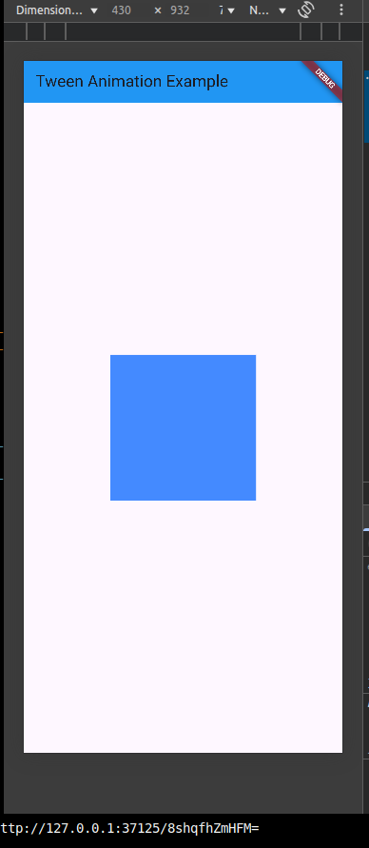
physics-based animation
import 'package:flutter/material.dart';
import 'package:flutter/physics.dart';

void main() {
runApp(const PhysicsAnimationApp());
}

class PhysicsAnimationApp extends StatelessWidget {
const PhysicsAnimationApp({super.key});

@override
Widget build(BuildContext context) {
return const MaterialApp(
debugShowCheckedModeBanner: false,
home: PhysicsAnimationPage(),
);
}
}

class PhysicsAnimationPage extends StatefulWidget {
const PhysicsAnimationPage({super.key});

@override
State<PhysicsAnimationPage> createState() => _PhysicsAnimationPageState();
}

class _PhysicsAnimationPageState extends State<PhysicsAnimationPage>
with SingleTickerProviderStateMixin {
late AnimationController _controller;
late Animation<Offset> _animation;

Offset _ballPosition = Offset.zero; // Relative to center

@override
void initState() {
super.initState();
_controller = AnimationController.unbounded(vsync: this);
_animation = _controller.drive(Tween(begin: Offset.zero, end: Offset.zero));
}

void _runSpringSimulation(Offset velocity) {
final spring = SpringDescription(
mass: 1,
stiffness: 200,
damping: 15,
);

// Simulate spring in X axis
final simX = SpringSimulation(spring, _ballPosition.dx, 0, velocity.dx);
// Simulate spring in Y axis
final simY = SpringSimulation(spring, _ballPosition.dy, 0, velocity.dy);

_controller.animateWith(_CombinedSimulation(simX, simY, (offset) {
setState(() {
_ballPosition = offset;
});
}));
}

@override
void dispose() {
_controller.dispose();
super.dispose();
}

@override
Widget build(BuildContext context) {
return Scaffold(
appBar: AppBar(
title: const Text('Physics-based Animation'),
backgroundColor: Colors.green,
),
body: GestureDetector(
onPanUpdate: (details) {
setState(() {
_ballPosition += details.delta;
});
},
onPanEnd: (details) {
// Convert pixels/ms to logical pixels/s
final velocity = details.velocity.pixelsPerSecond / 1000;
_runSpringSimulation(velocity);
},
child: Stack(
children: [
Center(
child: Transform.translate(
offset: _ballPosition,
child: Container(
width: 80,
height: 80,
decoration: const BoxDecoration(
shape: BoxShape.circle,
color: Colors.orange,
),
),
),
),
],
),
),
);
}
}

// Helper to combine two simulations (X and Y axes)
class _CombinedSimulation extends Simulation {
final Simulation simX;
final Simulation simY;
final void Function(Offset) onUpdate;

_CombinedSimulation(this.simX, this.simY, this.onUpdate);

@override
double x(double time) {
final value = Offset(simX.x(time), simY.x(time));
onUpdate(value);
return 0; // Not used
}

@override
double dx(double time) => 0;

@override
bool isDone(double time) => simX.isDone(time) && simY.isDone(time);
}

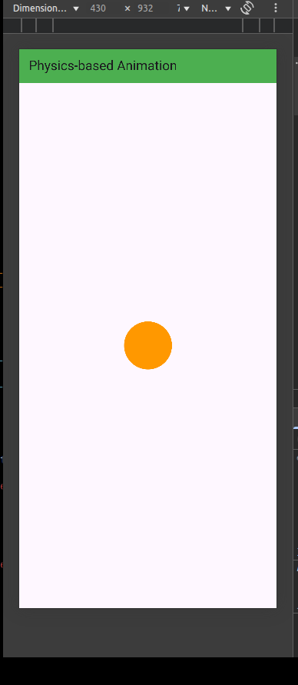
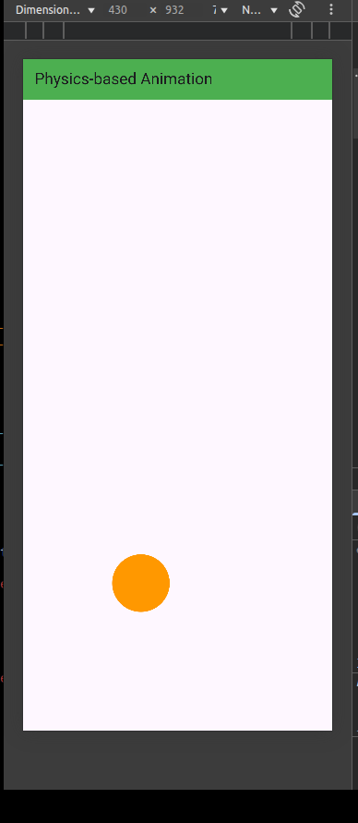
Out of box animation
import 'dart:math';
import 'package:flutter/material.dart';

void main() {
runApp(const OutOfBoxUniqueApp());
}

class OutOfBoxUniqueApp extends StatelessWidget {
const OutOfBoxUniqueApp({super.key});

@override
Widget build(BuildContext context) {
return const MaterialApp(
debugShowCheckedModeBanner: false,
home: OutOfBoxUniquePage(),
);
}
}

class OutOfBoxUniquePage extends StatefulWidget {
const OutOfBoxUniquePage({super.key});

@override
State<OutOfBoxUniquePage> createState() => _OutOfBoxUniquePageState();
}

class _OutOfBoxUniquePageState extends State<OutOfBoxUniquePage> {
final Random _random = Random();

Alignment _alignment = Alignment.center;
double _opacity = 1.0;

void _moveBall() {
setState(() {
// Random alignment (between -1 and 1 for both x and y)
_alignment = Alignment(
_random.nextDouble() * 2 - 1,
_random.nextDouble() * 2 - 1,
);

// Random opacity (between 0.3 and 1)
_opacity = _random.nextDouble() * 0.7 + 0.3;
});
}

@override
Widget build(BuildContext context) {
return Scaffold(
appBar: AppBar(
title: const Text("Unique Out-of-the-Box Animation"),
backgroundColor: Colors.teal,
),
body: GestureDetector(
onTap: _moveBall,
child: Container(
color: Colors.grey.shade200,
child: Stack(
children: [
AnimatedAlign(
alignment: _alignment,
duration: const Duration(seconds: 1),
curve: Curves.easeInOut,
child: AnimatedOpacity(
opacity: _opacity,
duration: const Duration(milliseconds: 800),
child: Container(
width: 80,
height: 80,
decoration: const BoxDecoration(
color: Colors.deepOrange,
shape: BoxShape.circle,
boxShadow: [
BoxShadow(
color: Colors.black26,
blurRadius: 8,
spreadRadius: 2,
)
],
),
),
),
),
],
),
),
),
);
}
}

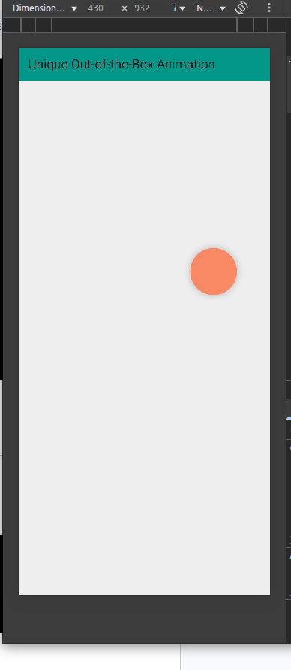
App container animation
import 'package:flutter/material.dart';

void main() {
runApp(const AnimatedContainerApp());
}

class AnimatedContainerApp extends StatelessWidget {
const AnimatedContainerApp({super.key});

@override
Widget build(BuildContext context) {
return const MaterialApp(
debugShowCheckedModeBanner: false,
home: AnimatedContainerPage(),
);
}
}

class AnimatedContainerPage extends StatefulWidget {
const AnimatedContainerPage({super.key});

@override
State<AnimatedContainerPage> createState() => _AnimatedContainerPageState();
}

class _AnimatedContainerPageState extends State<AnimatedContainerPage> {
double _width = 100;
double _height = 100;
Color _color = Colors.blue;
BorderRadiusGeometry _borderRadius = BorderRadius.circular(8);

void _changeShape() {
setState(() {
_width = _width == 100 ? 200 : 100;
_height = _height == 100 ? 150 : 100;
_color = _color == Colors.blue ? Colors.orange : Colors.blue;
_borderRadius = _borderRadius == BorderRadius.circular(8)
? BorderRadius.circular(50)
: BorderRadius.circular(8);
});
}

@override
Widget build(BuildContext context) {
return Scaffold(
appBar: AppBar(
title: const Text("AnimatedContainer Example"),
backgroundColor: Colors.purple,
),
body: Center(
child: AnimatedContainer(
width: _width,
height: _height,
decoration: BoxDecoration(
color: _color,
borderRadius: _borderRadius,
),
duration: const Duration(seconds: 1),
curve: Curves.easeInOut,
),
),
floatingActionButton: FloatingActionButton(
onPressed: _changeShape,
child: const Icon(Icons.play_arrow),
),
);
}
}

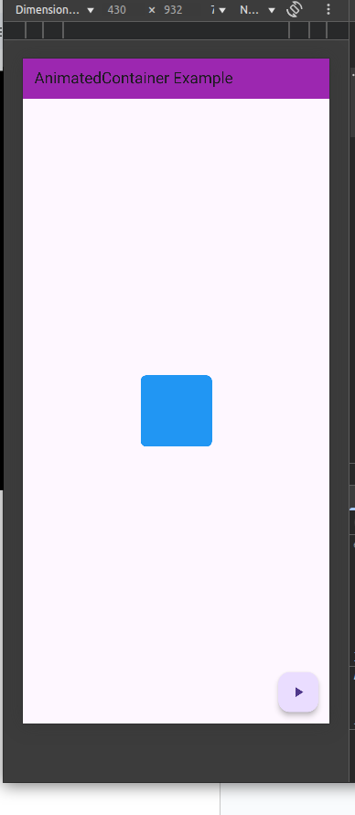
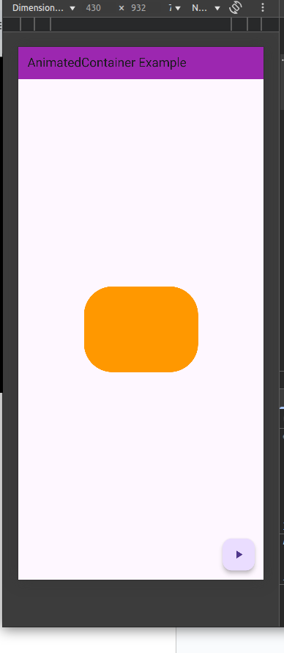
Fade out animation
import 'package:flutter/material.dart';

void main() {
runApp(const CrossFadeExampleApp());
}

class CrossFadeExampleApp extends StatelessWidget {
const CrossFadeExampleApp({super.key});

@override
Widget build(BuildContext context) {
return const MaterialApp(
debugShowCheckedModeBanner: false,
home: CrossFadePage(),
);
}
}

class CrossFadePage extends StatefulWidget {
const CrossFadePage({super.key});

@override
State<CrossFadePage> createState() => _CrossFadePageState();
}

class _CrossFadePageState extends State<CrossFadePage> {
bool _showFirst = true;

void _toggleView() {
setState(() {
_showFirst = !_showFirst;
});
}

@override
Widget build(BuildContext context) {
return Scaffold(
appBar: AppBar(
title: const Text("AnimatedCrossFade Example"),
backgroundColor: Colors.deepPurple,
),
body: Center(
child: AnimatedCrossFade(
firstChild: Container(
width: 200,
height: 200,
color: Colors.blue,
child: const Center(
child: Text(
'First View',
style: TextStyle(color: Colors.white, fontSize: 18),
),
),
),
secondChild: Container(
width: 300,
height: 150,
color: Colors.orange,
child: const Center(
child: Text(
'Second View',
style: TextStyle(color: Colors.white, fontSize: 18),
),
),
),
crossFadeState: _showFirst
? CrossFadeState.showFirst
: CrossFadeState.showSecond,
duration: const Duration(seconds: 1),
),
),
floatingActionButton: FloatingActionButton(
onPressed: _toggleView,
child: const Icon(Icons.swap_horiz),
),
);
}
}

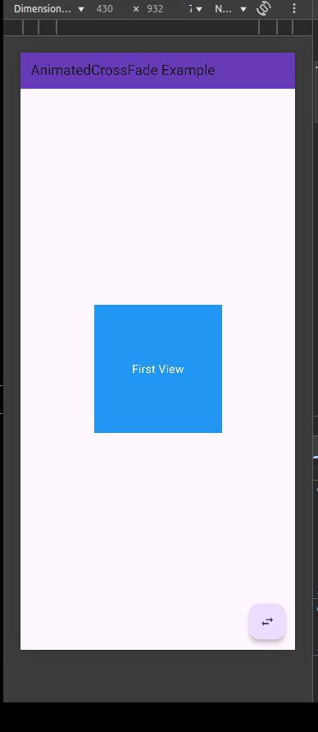
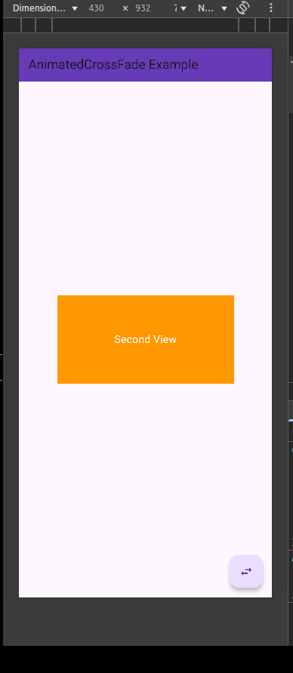
Animated list
import 'package:flutter/material.dart';

void main() {
runApp(const AnimatedListExampleApp());
}

class AnimatedListExampleApp extends StatelessWidget {
const AnimatedListExampleApp({super.key});

@override
Widget build(BuildContext context) {
return const MaterialApp(
debugShowCheckedModeBanner: false,
home: AnimatedListPage(),
);
}
}

class AnimatedListPage extends StatefulWidget {
const AnimatedListPage({super.key});

@override
State<AnimatedListPage> createState() => _AnimatedListPageState();
}

class _AnimatedListPageState extends State<AnimatedListPage> {
final GlobalKey<AnimatedListState> _listKey = GlobalKey<AnimatedListState>();
final List<String> _items = [];

int _counter = 1;

void _addItem() {
final String newItem = "Item $_counter";
_items.insert(0, newItem);
_listKey.currentState!.insertItem(0, duration: const Duration(milliseconds: 500));
_counter++;
}

void _removeItem(int index) {
final removedItem = _items[index];
_items.removeAt(index);
_listKey.currentState!.removeItem(
index,
(context, animation) => _buildItem(removedItem, animation),
duration: const Duration(milliseconds: 500),
);
}

Widget _buildItem(String item, Animation<double> animation) {
return SizeTransition(
sizeFactor: animation,
child: Card(
margin: const EdgeInsets.symmetric(vertical: 5, horizontal: 10),
child: ListTile(
title: Text(item),
trailing: IconButton(
icon: const Icon(Icons.delete, color: Colors.red),
onPressed: () => _removeItem(_items.indexOf(item)),
),
),
),
);
}

@override
Widget build(BuildContext context) {
return Scaffold(
appBar: AppBar(
title: const Text("AnimatedList Example"),
backgroundColor: Colors.green,
),
body: AnimatedList(
key: _listKey,
initialItemCount: _items.length,
itemBuilder: (context, index, animation) {
return _buildItem(_items[index], animation);
},
),
floatingActionButton: FloatingActionButton(
onPressed: _addItem,
child: const Icon(Icons.add),
),
);
}
}

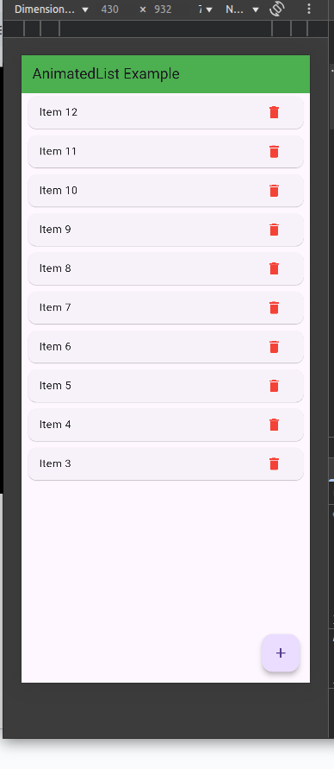
Hero animation
import 'package:flutter/material.dart';

void main() {
runApp(const HeroAnimationApp());
}

class HeroAnimationApp extends StatelessWidget {
const HeroAnimationApp({super.key});

@override
Widget build(BuildContext context) {
return const MaterialApp(
debugShowCheckedModeBanner: false,
home: HeroFirstPage(),
);
}
}

class HeroFirstPage extends StatelessWidget {
const HeroFirstPage({super.key});

@override
Widget build(BuildContext context) {
return Scaffold(
appBar: AppBar(
title: const Text("Hero Animation - Page 1"),
backgroundColor: Colors.blue,
),
body: Center(
child: GestureDetector(
onTap: () {
Navigator.push(
context,
MaterialPageRoute(builder: (_) => const HeroSecondPage()),
);
},
child: Hero(
tag: 'hero-image',
child: ClipRRect(
borderRadius: BorderRadius.circular(16),
child: Image.network(
"https://flutter.github.io/assets-for-api-docs/assets/widgets/owl.jpg",
width: 150,
height: 150,
fit: BoxFit.cover,
),
),
),
),
),
);
}
}

class HeroSecondPage extends StatelessWidget {
const HeroSecondPage({super.key});

@override
Widget build(BuildContext context) {
return Scaffold(
appBar: AppBar(
title: const Text("Hero Animation - Page 2"),
backgroundColor: Colors.blue,
),
body: Center(
child: Hero(
tag: 'hero-image',
child: ClipRRect(
borderRadius: BorderRadius.circular(0),
child: Image.network(
"https://flutter.github.io/assets-for-api-docs/assets/widgets/owl.jpg",
width: 300,
height: 300,
fit: BoxFit.cover,
),
),
),
),
);
}
}

